Better outcomes for adopted children and value of adoptive placements generated cost savings of £4.2 billion in 2021
- New analysis shows billions of savings each year across England, Wales and Scotland as a result of children in public care being adopted.
- Children who are adopted are likely to have better health, achieve more in education and have better employment prospects than children in alternative permanent arrangements, according to the evidence currently available
- Falling numbers of children being adopted mean that this value to children, families and society is diminishing over time.
14th December 2022 – New analysis has revealed that at least £4.2 billion in value was generated across England, Wales and Scotland in 2021 when 3,359 children were adopted – including savings of £3.6 billion to local authorities, £541 million to the economy, and £34 million to the NHS. The modelling, which compared the outcomes of children who were adopted with those in other permanent placements found that the value created for adopted children, families and society is at least £1.3million for every child adopted.
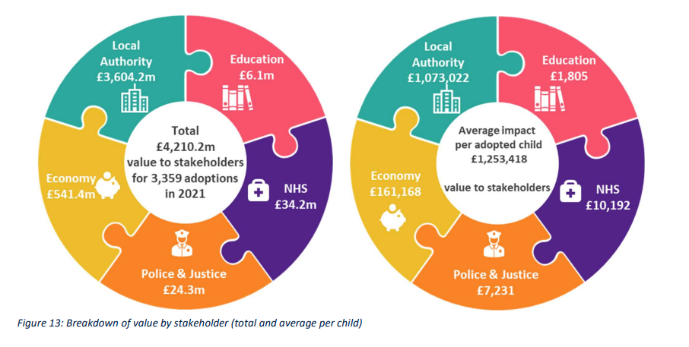
The analysis by Sonnet Advisory & Impact, commissioned by the Consortium of Voluntary Adoption Agencies (CVAA), shows that this value is created through two key channels: the improved outcomes adoption offers relative to staying in care or living in special guardianship placements, and the lower financial cost to local authorities of adoption compared to foster and residential homes. According to the available evidence, adopted children and young people have enhanced outcomes across health, education and future employment compared to other placements, decreasing reliance on publicly funded services and support in childhood and later life. Additionally most adoptive parents do not receive financial support from the state, in contrast to foster and residential carers, which adds to the value adoption can bring – when it is in the best interests of the child.
Adoption is only right for a small number of children who cannot remain with their birth families. Yet the scale of the benefits it brings to those children – and to society as a whole – appear to be declining year-on-year as the number of children being placed for adoption falls. Despite policies supportive of adoption introduced over the last decade, the number of children adopted peaked in England in 2015 at 5,360, and has since fallen to 2,950 in 2022. This trend has occurred despite increased numbers of children needing to live in safe homes apart from their families of origin, with numbers of children in care in England up 25% since 2010 – and at their highest levels since records began.
With the number of children in foster care and in kinship / Special Guardianship arrangements increasing each year, this report evaluates the benefits and limitations of these placements alongside adoption, to consider what those children’s lives may have been like if they had not been adopted. For example:
- Long term foster care: Foster care, like adoption, means that children are looked after in a family environment by highly committed carers. It also brings benefits in terms of the statutory support children are eligible for, and the potential for stronger ties with birth families owing to the clear legal duty to promote contact. However, fostered children are negatively impacted by their care ending at 18 – or 21 if they have been fortunate to benefit from the ‘Staying Put’ scheme – and placement instability, resulting in children having to move homes regularly. Most foster placements in England last between 6 months and one year (18%), and only 4% last over 5 years.
- Kinship and Special Guardianship: The number of children living in these arrangements is rapidly increasing – SGOs in England rose by 200% between 2010 and 2021, giving many more children the opportunity to remain living with their wider family networks. This continuing connection brings value to children’s sense of identity. However, the relative newness of Special Guardianship orders means there is little evidence around the long term outcomes of children living with Special Guardians. Adequate support for carers remains a major issue which threatens the quality and longevity of placements.
- Adoption: One of the key value drivers of adoption is that it provides stability and maintains a legal link between the child and the parent beyond the age of 18 years, which supports transitions into adulthood and beyond. However, the strong evidence of the benefits to adopted people of maintaining connections with their birth families needs to be acknowledged and built into practice. There is a misconception that adoption severs all ties with birth families but this does not reflect current practice which is making concerted efforts to improve children’s ongoing links with their families of origin and preparing adopters to support this.
Professor Jim Clifford, CEO of Sonnet Advisory & Impact commented: “Adoption is a tremendously valuable plan for those children that can’t return to their birth families. Each child for whom it would work that doesn’t get that chance costs our economy and services over £1.3m. There appears to be a deep misunderstanding of the options, dismissing adoption because the child is too old, or because they will be permanently separated from birth family, amongst other reasons. Neither is really true, and we should be far more reluctant to dismiss this strong form of permanence for the child.”
“The balance of decision-making for children needs review, as alternatives are considered in many cases without an adoption specialist in the room. The Guardians ad Litem are a key part of the decision-making and guidance, so their awareness and training needs review in light of the developing profile of adoption. The use of cost for family-finding for adoption as a reason for dismissing adoption as a plan is of particular concern, notably when the overall value of pursuing adoption is not well understood. There are some real opportunities here to transform practice for the better.”
Andrew Webb, Chair of CVAA, added: “It’s a rare thing when research concludes that the best outcomes for children can be achieved at the lowest cost to the state. With the country in recession and set for extremely challenging financial times over the years ahead, it would be madness not to give serious consideration to these findings, and we urge governments in all UK nations to act on falling adoption numbers now. CVAA has always maintained that adoption is an intervention for the few, not the many – but the risk of adoption slowly vanishing as an option for children who cannot safely live at home is a grave concern. Evidence continues to show the life-changing and unrivalled benefits adoption holds for children, and with the sector working hard to improve the contact children have with their birth families, there is no justification for letting this trend continue unchallenged.”
The findings of the report indicate that a number of actions need to be taken across England, Wales and Scotland. These include:
- The adoption sector needs to make a step-change in the way it supports children’s lifelong connections with birth families and other significant people in their lives: This includes exploring how connections can be maintained for every child, where safe to do so and in the right form for that child, and making sure that ongoing support is available for everyone involved – children, young people, birth families and adoptive families.
- Local authority children’s services and the social work profession need to:
  - Investigate whether social workers making care planning decisions for children have a solid understanding of all the different permanency options, including the benefits and limitations of each option, and the latest research on children’s outcomes. They need to consider whether social workers have sufficient support available to confidently present all/any of these permanency options as care plans to the Courts, depending on what is best for the child.
  - This also applies to CAFCASS, which should review the knowledge of Guardians ad Litem regarding the relative appropriateness of the different forms of permanence and how they can meet the needs of children.
  - Explore multi-agency approaches to care planning which incorporate the views of adoption, Special Guardianship and care experts.
- The Judiciary needs to ensure that judges are equipped with feedback on the outcomes of their decisions (as per the English care review recommendations) and are provided with resources and/or training on good practice and outcomes in adoption and Special Guardianship to improve their understanding of how these permanence options can benefit children with various needs.
- Governments in all nations need to:
  - Dedicate adequate resources to services supporting children and families to maintain lifelong family connections, and in doing so follow through with recommendations made in the English and Scottish independent care reviews.
  - Invest in Special Guardianship and wider kinship care arrangements to ensure that these carers can access the same level of training provided by other forms of permanence, and financial assistance where needed.
  - Evaluate the long term outcomes of children subject to Special Guardianship Orders and Adoption Orders to gain a more in-depth understanding of the different routes to permanence. A review should look in particular at the support and stability provided by Special Guardianship placements, how relationships with birth parents are supported, and what happens to children after the age of 18.
The full report is available here: https://cvaa.org.uk/wp-content/uploads/2022/12/CVAA-The-value-of-adoption-report-final-Nov-22.pdf
Accompanying infographics are available to download here and here.

INFORMATION FOR EDITORS
If you would like to arrange an interview with CVAA spokesperson / leader of a voluntary adoption agency to discuss the findings further, or would like more information about this research please contact:
Alice Talbot, Head of Policy and Member Services, CVAA on:
Email: alice.talbot@cvaa.org.uk
Mobile: 07525 176427

About Sonnet Advisory and Impact
Sonnet is an impact-focused, financial, research, design and strategic consultancy with deep connections in the social and charity sectors. Sonnet is partially owned by Sheffield Hallam University, structured as a Community Interest Company, and regulated as a firm of chartered accountants. It provides charities, social enterprises, and other socially-minded clients with advice and solutions to enhance and sustain their impact. Further details of its work can be found at www.sonnetimpact.co.uk.

About the Consortium of Voluntary Adoption Agencies (CVAA)
This report has been commissioned by the CVAA, the body that represents Voluntary Adoption Agencies (VAAs). VAAs are not-for-profit bodies that find, prepare, train and approve families and guide the placement of children for adoption, supporting local authorities (LAs) and statutory agencies (including Regional Adoption Agencies (RAAs)) to find stable and permanent homes for children who cannot live with their birth families.
The CVAA’s mission is to achieve excellence in the adoption system through harnessing the collective expertise, commitment and innovation of the voluntary adoption sector, working together for children, families and adopted adults. Through lobbying and advocacy, the CVAA upholds this central principle and works to amplify the voice and influence of voluntary agencies, using their collective wisdom and the integrity of their work to achieve positive change for children.
For more information please visit CVAA’s website here: https://cvaa.org.uk/

One limitation of the study is that there is insufficient evidence comparing outcomes of children in short-term compared to long term foster care. However statistics illustrate the low chances of children finding permanence through long-term foster care, even if that is the plan for them.

